PIRATA FR 26 CRUISE
PIRATA maintains 18 buoys in the Tropical Atlantic; this induces yearly dedicated cruises ensured by Brazil, US and French partners. France is in charge of 6 ATLAS moorings (at 23°W-0°N, 10°W-0°N, 0°E-0°N, 10°W-6°S, 10°W-10°S, 8°E-6°S) and 2 currentmeter (ADCP) moorings (at 23°W-0°N and 10°W-0°N). The last French PIRATA cruise (PIRATA FR26) was carried out from March 7th to April 13rd, 2016, from Mindelo (Cabo-Verde), onboard the R/V THALASSA.
During this PIRATA FR26 cruise, the French PIRATA group notably ensured:
- The deployment of a new ADCP mooring at 0°E-0°N, that is a commitment of PIRATA-FR towards the PREFACE EU program (MS15); such a mooring will allow some current measurements at three longitudes along the equator. The ADCP moorings at 10°W-0°N and 23°W-0°N were serviced in 2015, respectively in March during PIRATA FR25 and in October during a GEOMAR cruise.
- The servicing of the PIRATA/PREFACE ATLAS buoy at 6°S-8°E, off Congo, that is also a commitment of PIRATA-FR toward PREFACE (MS8).
- The deployment of two new PIRATA T-Flex systems at 23°W-0°N and 10°W-10°S, that will progressively replace the ATLAS ones.
Presently, due to an increasing need of real time data and parameters induced by progresses in operational systems and climate research, NOAA developed a new T-Flex system to progressively replace the ATLAS. These new T-Flex systems will allow: i) to deploy more oceanographic sensors along the mooring line with data transmission in real time; ii) to ensure more reliable data transmission with higher time resolution (every hour with Iridium); iii) to double atmospheric sensors in order to reduce data acquisition loss induced by sensors failure; iv) to add systematically current sensors at subsurface (Aquadopp); v) to increase the sensors security in order to limit the impact of eventual vandalism actions or chocks; vi) to ensure a higher flexibility of the sensors types that could be added along the moorings (so to be less limited by sensors technology); vii) to ensure a longer autonomy of moorings (that could be extended up to 18 months).
After a 1st T-Flex deployment by US at 12°N-23°W in 2015, these three new systems open a new era for PIRATA, with more data in real-time, potentially more sensors etc...

During this PIRATA FR26 cruise, the French PIRATA group also ensured:
- The servicing of the 3 other ATLAS sites at 0°E-0°N, 10°W-6°S, and 10°W-0°E.
- The servicing of the CO2 parameters sensor installed at 10°W-6°S from 2006 (also component of the AtlantOS WP3.5; PI: Nathalie Lefèvre).
- The deployment of 15 surface drifting buoys (SVP-B), as contribution of Meteo-France to the AtlantOS WP3.6 (PI: Pierre Blouch).
- The deployment of 6 ARGO profilers (also as contribution to CORIOLIS), three of them with double programming (so allowing some profiles every two days during three months from the surface down to 300m depth).
- The servicing of turbulence sensors (Xpods), installed from 2014 at 23°W-0°N and 10°W-0°N (5 on each mooring between 20m and 80m) (collaboration with Oregon State University, Corvallis, USA ; PI: Jim Moum).
- The servicing of acoustic receivers (OTN), installed from 2014 at the PIRATA buoys (one per site) (collaboration with Dalhousie University, Halifax, Nova Scotia, Canada ; PI : Frederick G. Whoriskey).
- 50 CTDO2-LADCP profiles (from the surface down to 2000m depth; so useful for ARGO profilers validation) every ½° (latitude/longitude) along 23°W, 10°W (done yearly), 0°E, and 6°S (around the ATLAS buoy at 6°S-8°E). Data transmitted in quasi-real time to CORIOLIS for operational centers.
- 70 temperature profiles (XBT) during transits. Data transmitted in quasi-real time to CORIOLIS for operational centers.
- 615 sea water samplings (at the surface and during CTDO2/LADCP profiles) to analyze salinity, dissolved oxygen, nutrients, carbon parameters (DIC et TA) and primary production (pigments).
- Acoustic measurements (EK60 sounders: 6 vertical and one transversal) all along the trackline of the vessel and, if possible, to proceed to plankton sampling (from the surface down to about 200m) with a « bongo » net at the ATLAS sites.
- Continuous measurements, all along the trackline, of the sea surface temperature and salinity with the thermosalinograph, fluorimetry and meteorological parameters.
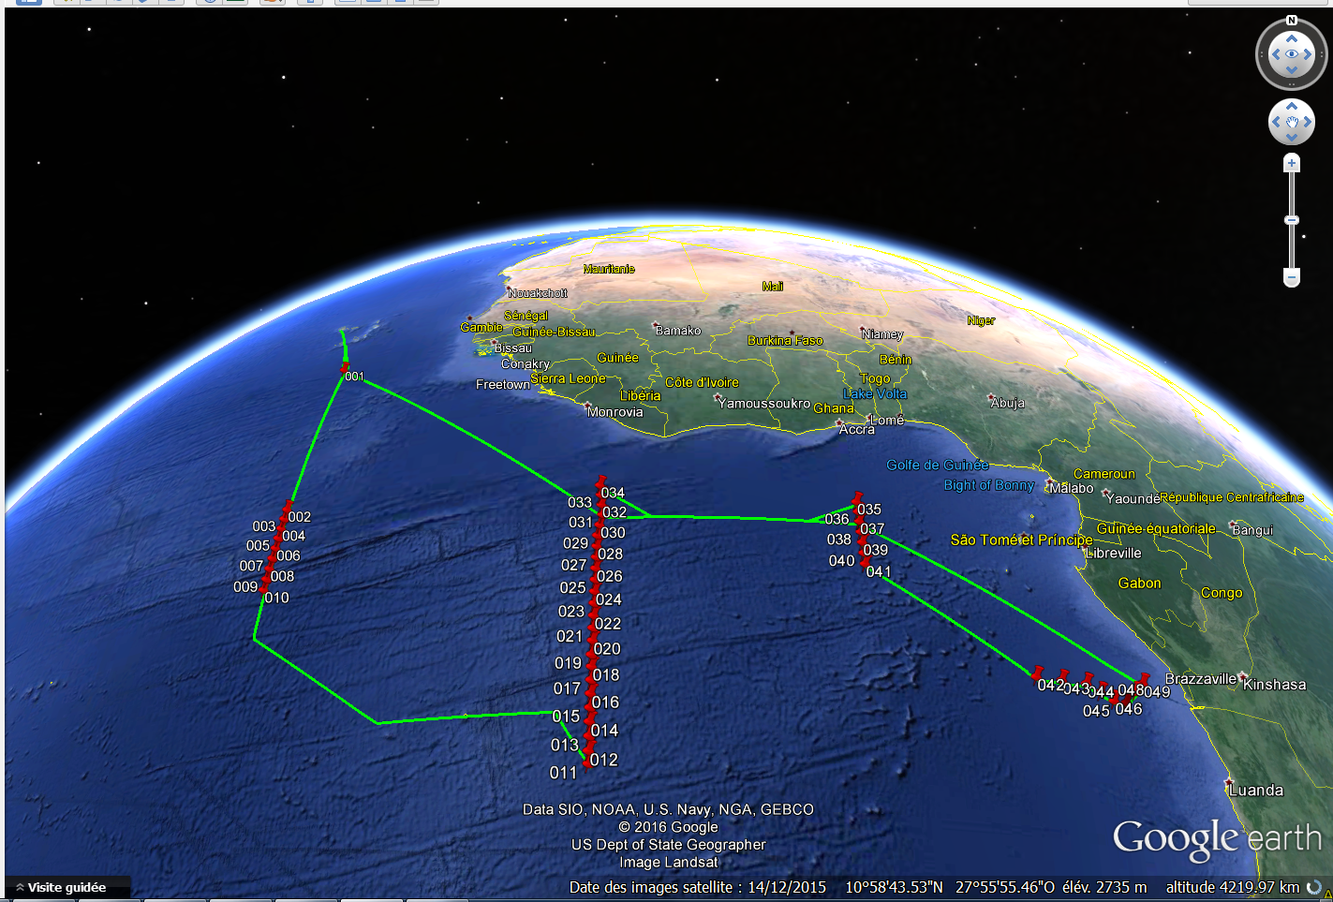
Trackline of the PIRATA FR26 cruise along with CTDO2/LADCP profiles positions (Courtesy: J.Grelet, IRD).
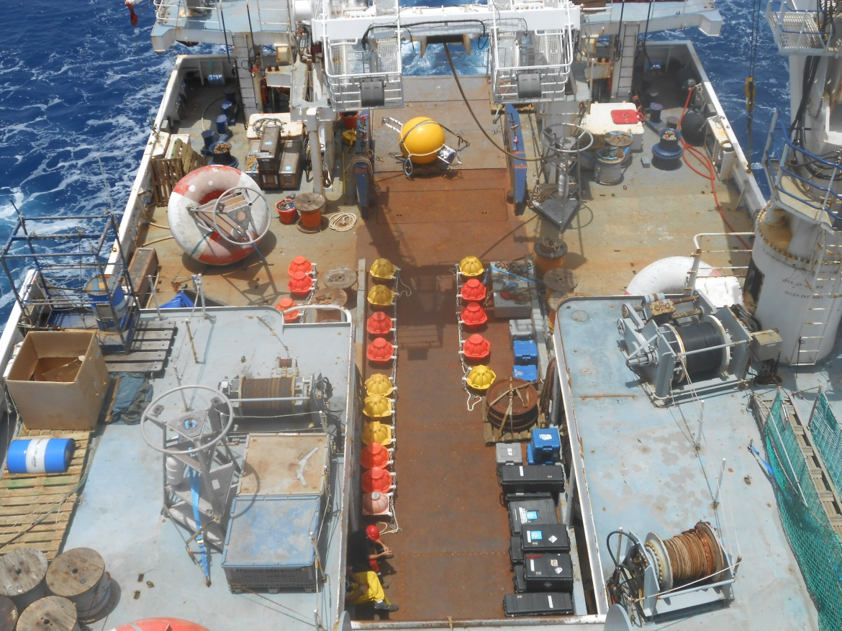
The ADCP mooring on the bridge before its deployment (Courtesy: B.Bourlès, IRD).
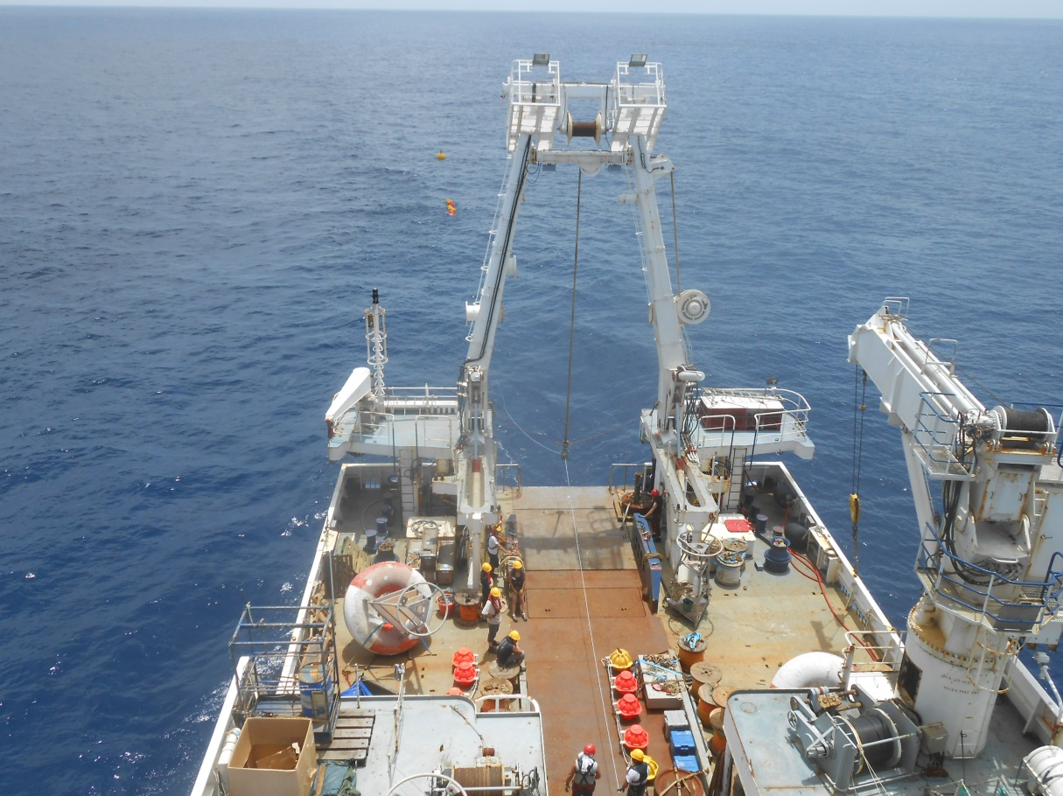
The ADCP mooring deployment (Courtesy: B.Bourlès, IRD).

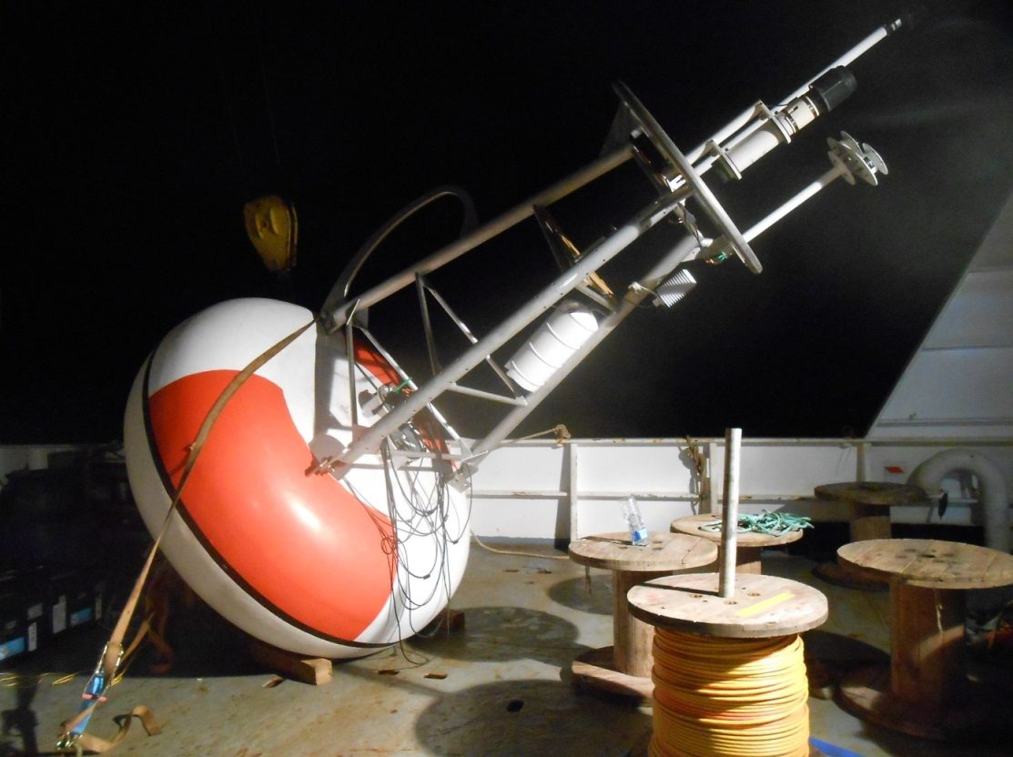
T-FLEX buoy before its deployment at 23°W-0°N (Courtesy: B.Bourlès, IRD).
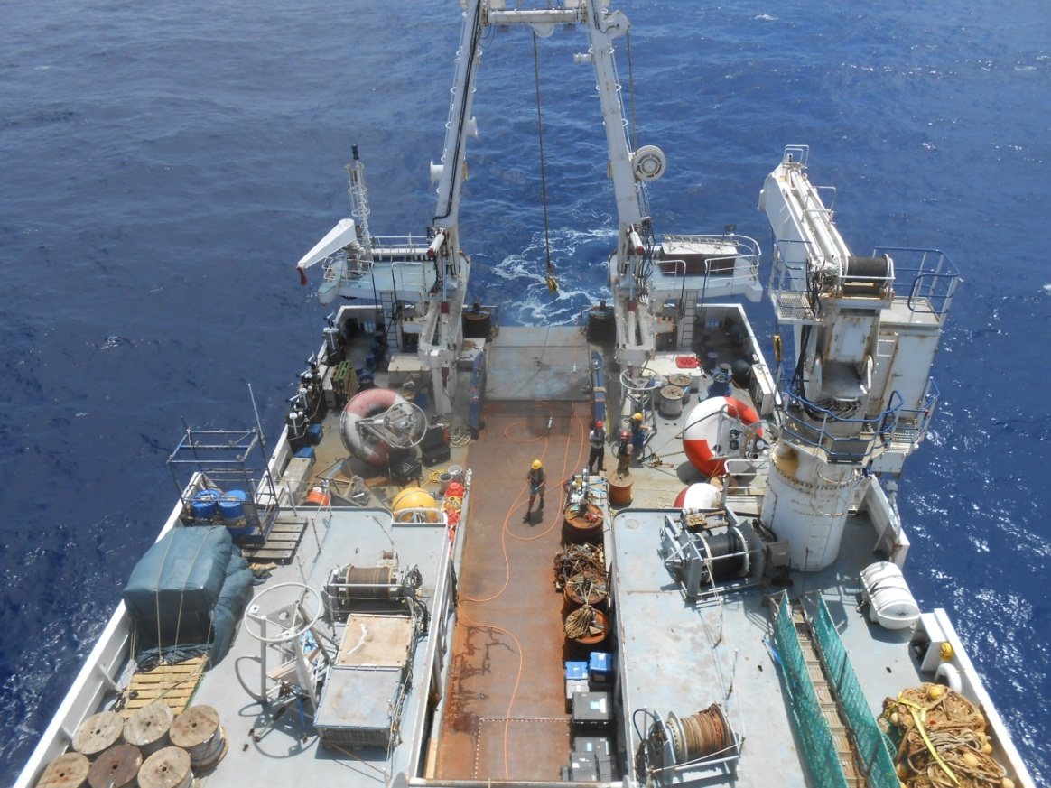
Last preparation of the T-FLEX buoy before its deployment at 10°W-10°S and sensors installation along the 1st 60 meters of the cable; the buoy of the left is the ATLAS just retrieved, the TFLEX is on the right (Courtesy: B.Bourlès, IRD).
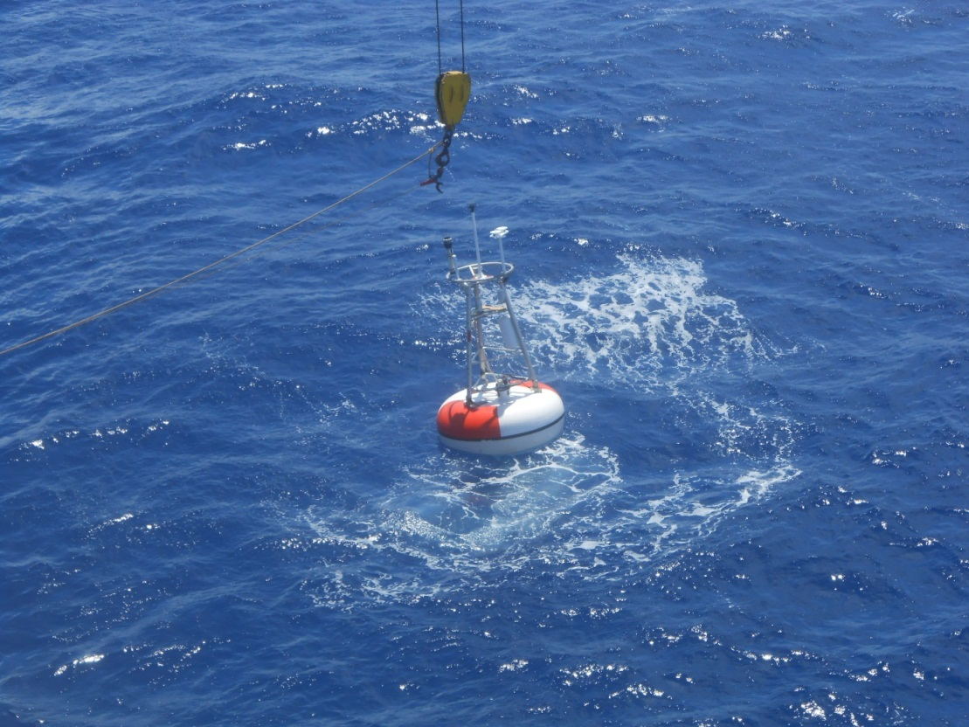
T-FLEX buoy deployment at 10°W-10°S (Courtesy: B.Bourlès, IRD).

